PROJECT REPORT TEMPLATE

INTRODUCTION

Customer relationship management (CRM) is a technology for managing all your company’s relationships and interactions with customers and potential customers. A CRM system helps companies stay connected to customers, streamline processes, and improve profitability.

OVERVIEW

Schools are facing more competition than ever before, and they need to find innovative ways to attract and retain students. One solution that many schools are turning to is School CRM software. This technology helps schools manage their relationships with students and parents, and it can be a powerful tool for increasing admissions. In this blog, we will explore what is CRM software for Schools, how it works, and how it can help in boosting enrollment and improving student engagement.

PURPOSE

$*$ A school CRM (Customers Relationship Management), software is a specialized tool designed to manage and track student interactions, data, and automate tasks related to student recruitment, enrollment, and retention.

$*$ This type of software is aimed at simplifying and streamlining the enrollment and retention process and provides valuable insights into student behaviour and preferences, which can help schools and preschool to make data-driven decisions.

PROBLEM DEFINITION AND DESIGN THINKING

EMPATHY MAP

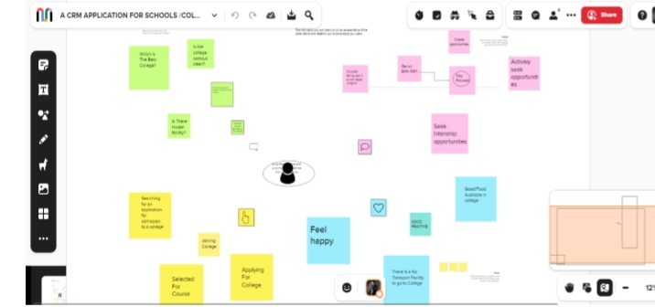

IDEATION AND BRAINSTORMING MAP SCREENSHOT

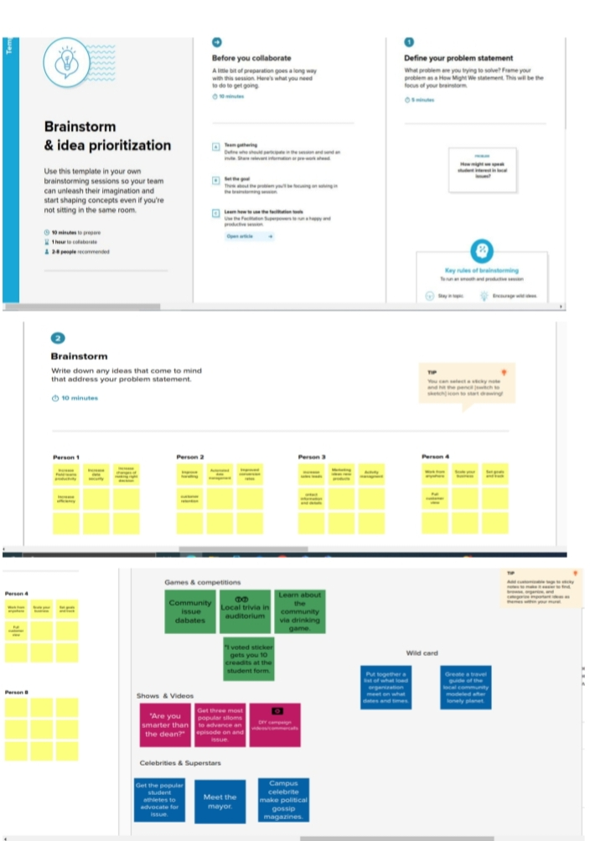

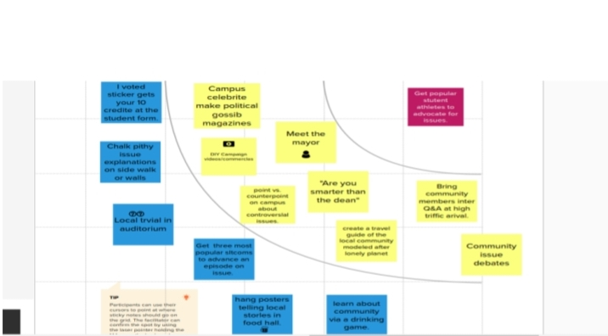

RESULT

DATA MODEL

|  |  |
| --- | --- |
| OBJECT NAME | FIELDS IN THE PROJECT |
| Object-1 | FIELD LABEL: Phone Number  DATA TYPE: Phone |
| Object-2 | FIELD LABEL: Schools  DATA TYPE: Picklist |
| Object-3 | FIELD LABEL: Parent address  DATA TYPE: Text |

ACTIVITY AND SCREENSHOT

CREATE SALESFORCE ORG-CREATING DEVELOPER ACCOUNT

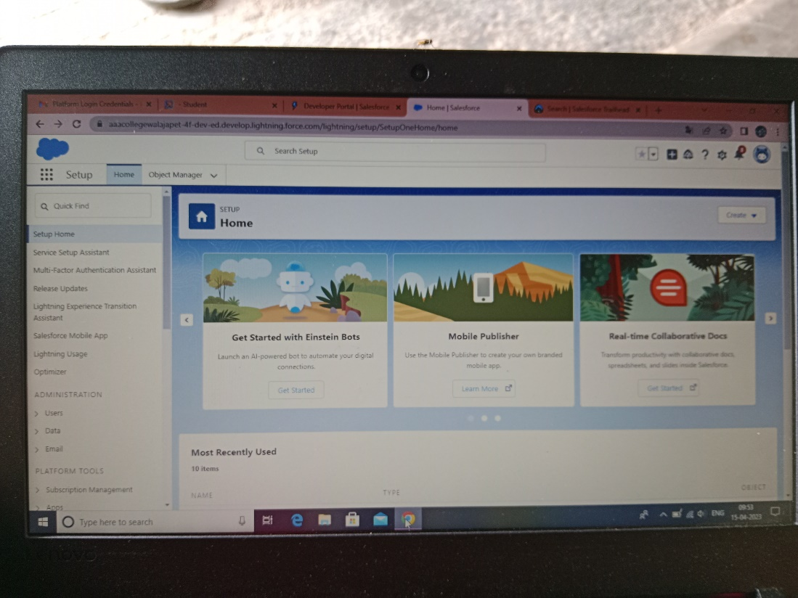

OBJECT

CREATION OF SCHOOL OBJECT

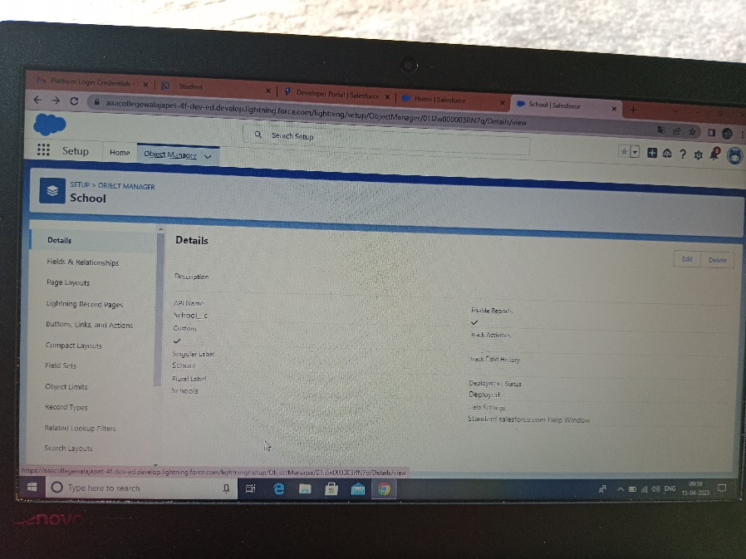

CREATION OF STUDENT OBJECT

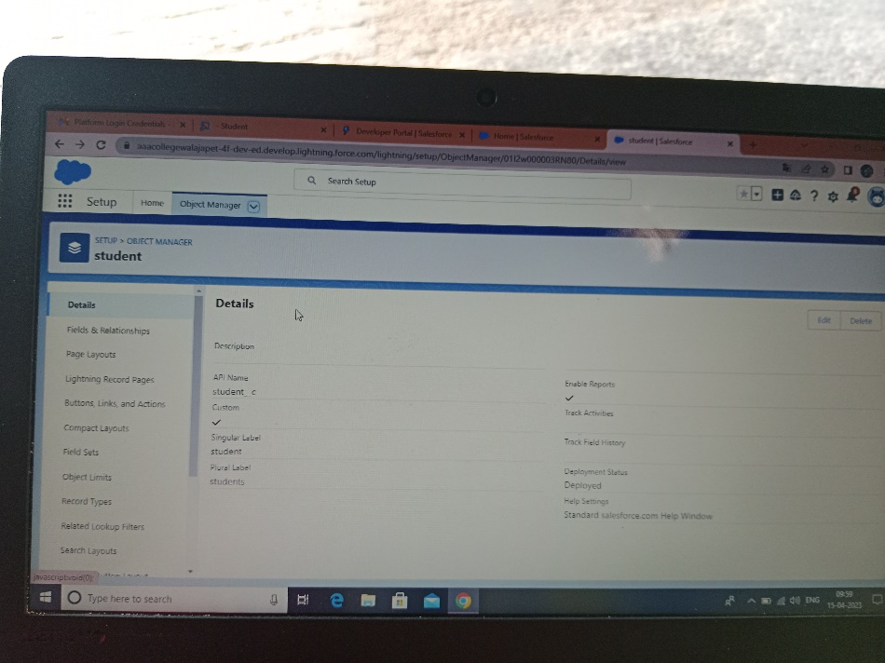

CREATION OF PARENT OBJECT

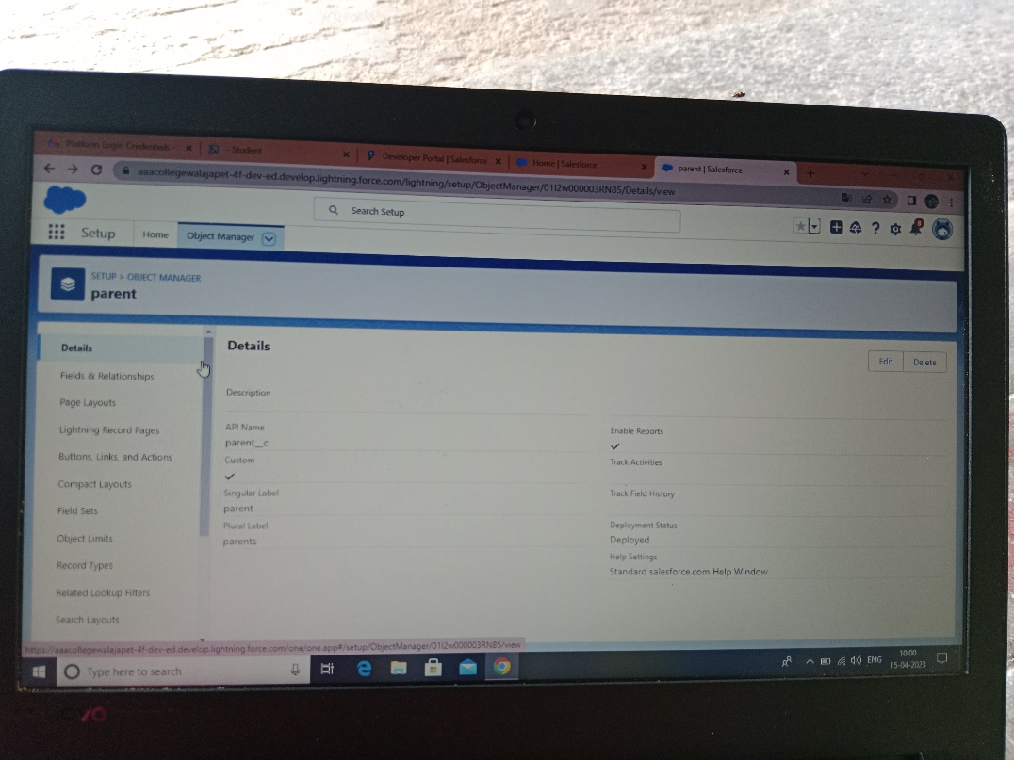

LIGHTING APP

CREATE THE SCHOOL MANAGEMENT APP

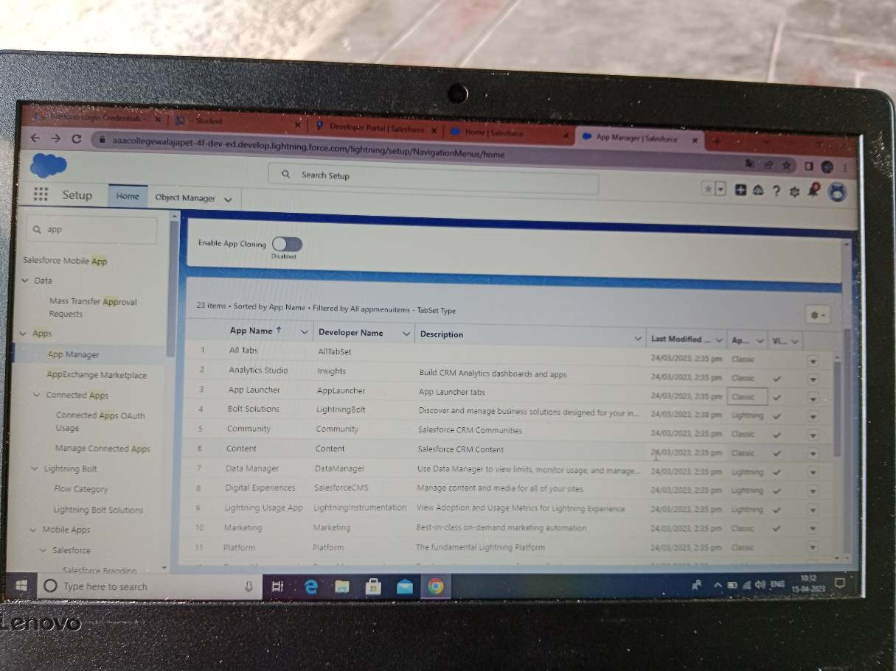

FIELD AND RELATIONSHIP

CREATION FIELD FOR THE SCHOOLS OBJECTS

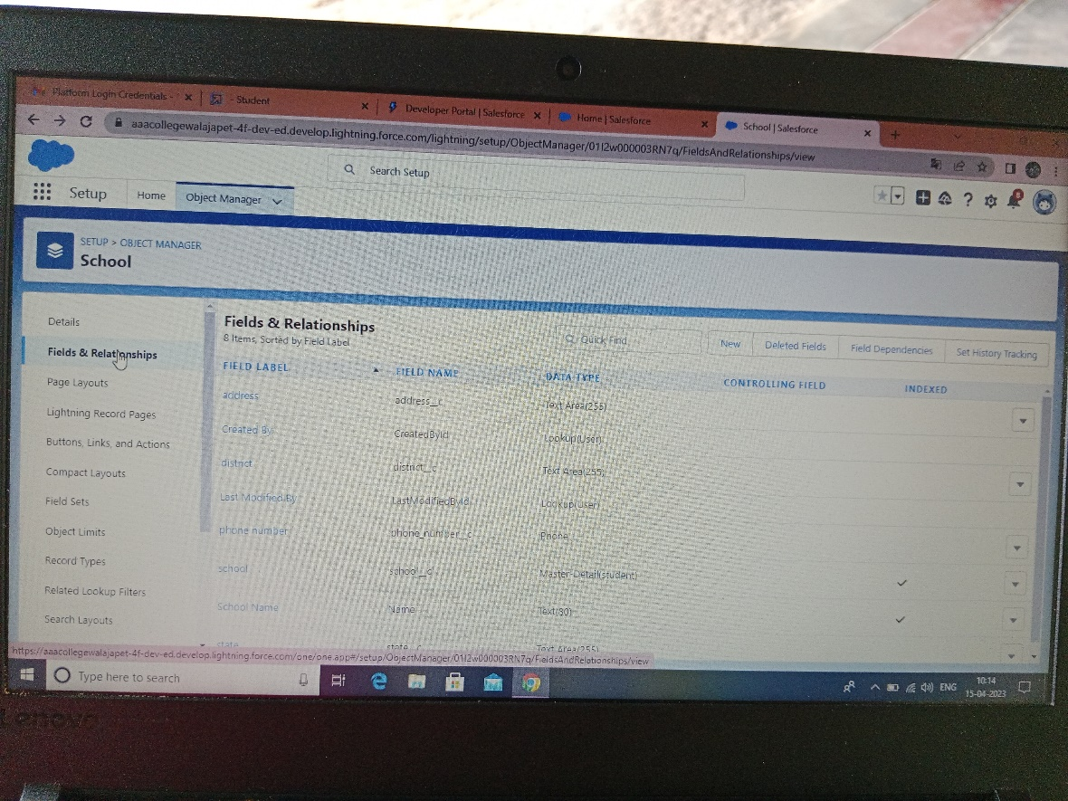

CREATION OF FIELDS FOR THE STUDENT OBJECTS

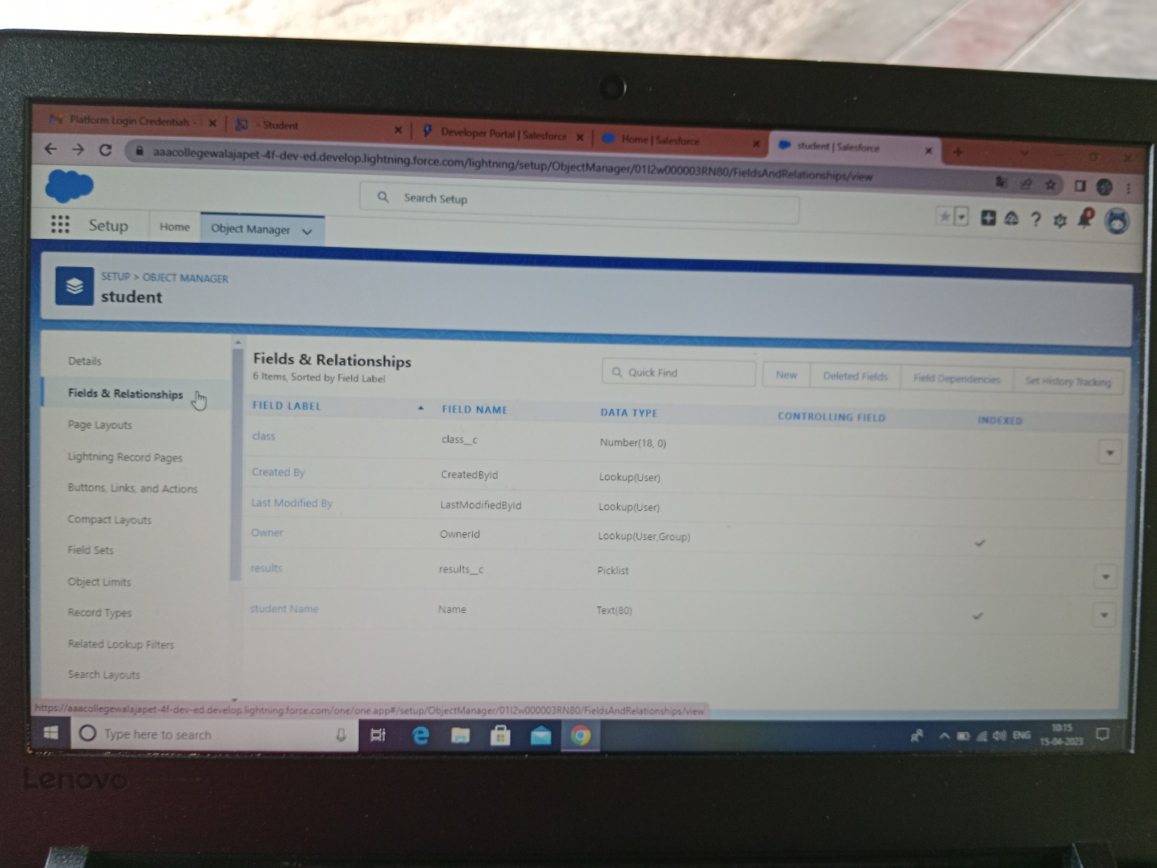

CREATION OF FIELDS FOR THE PARENT OBJECT

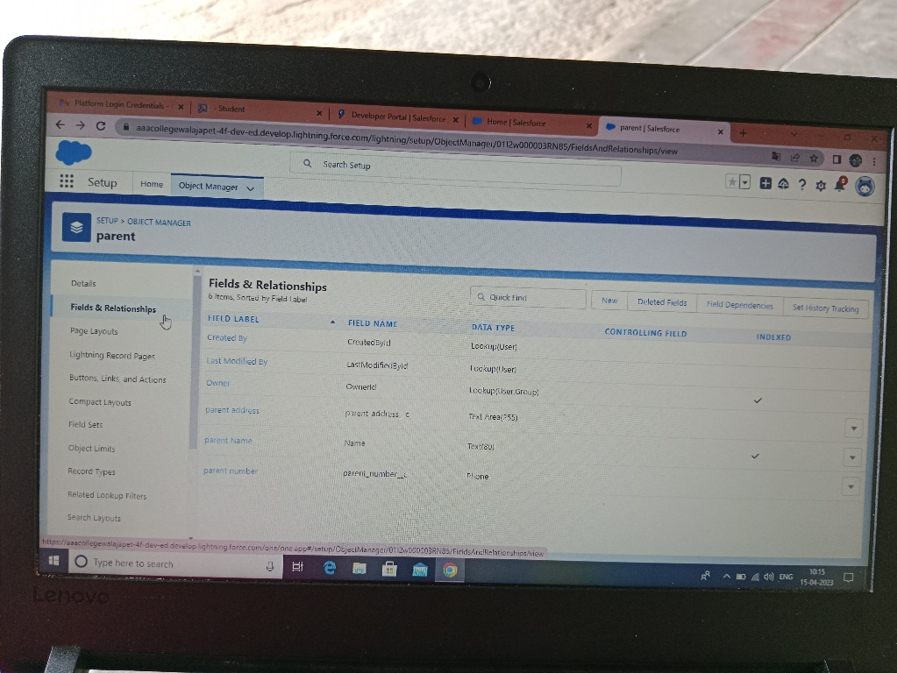

PROFILE

CREATION ON PROFILE

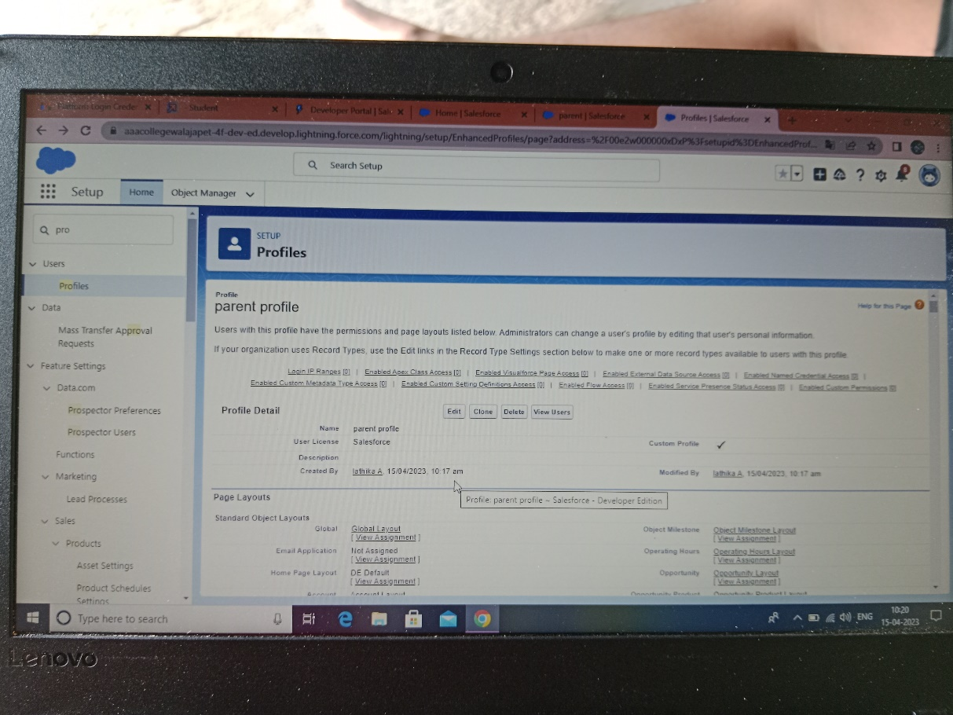

USERS

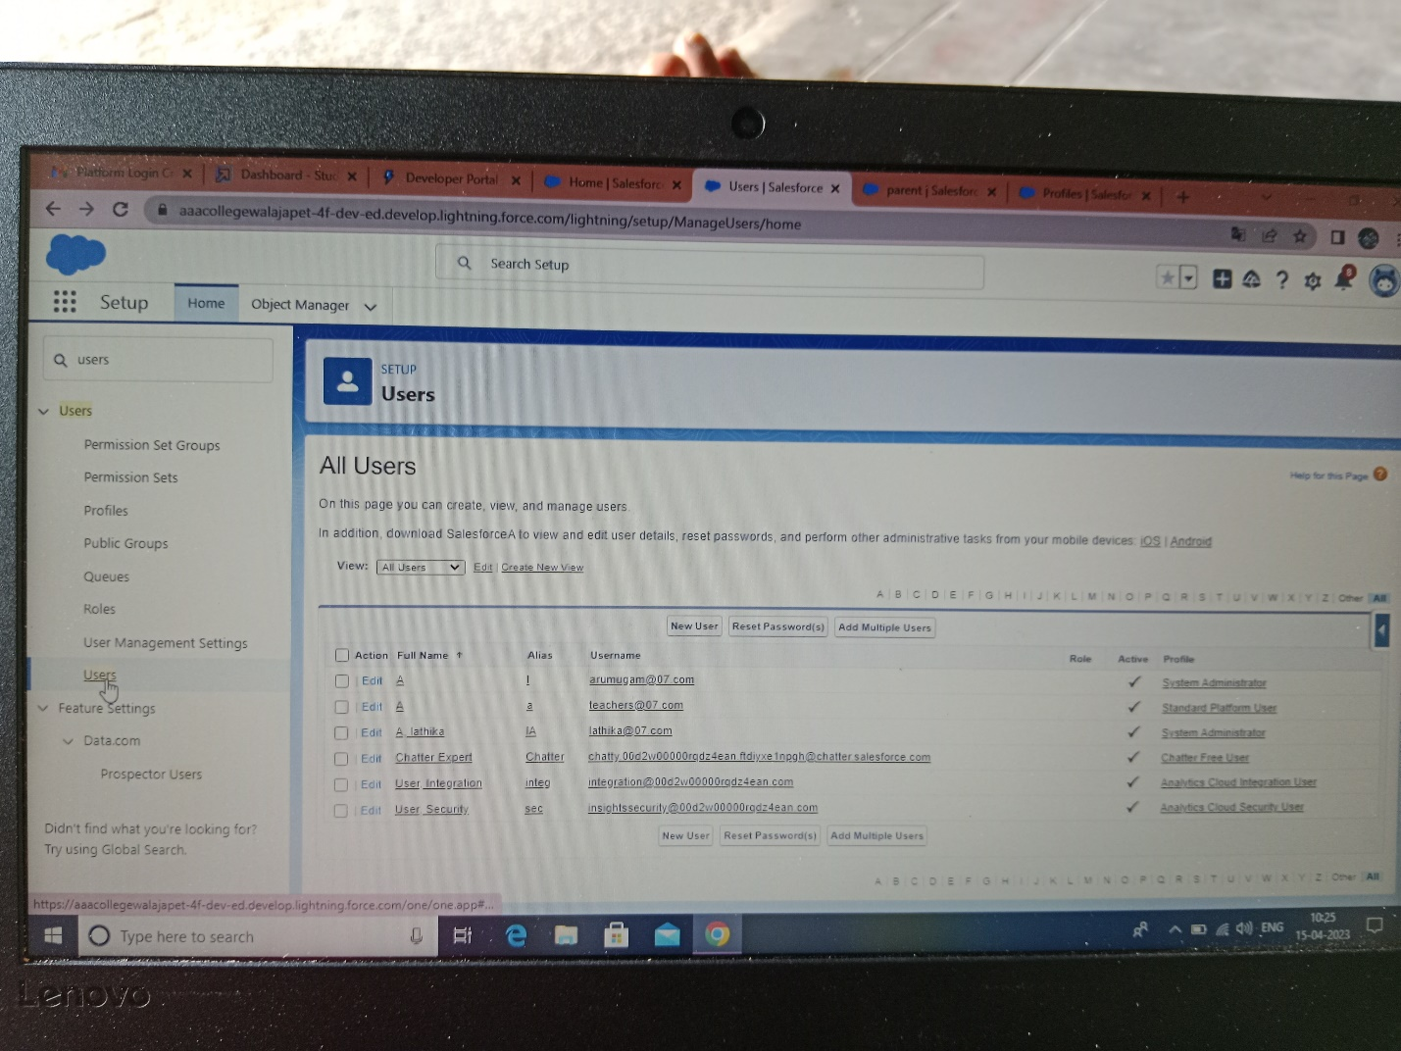

PERMISSION SETS

PERMISSION 1

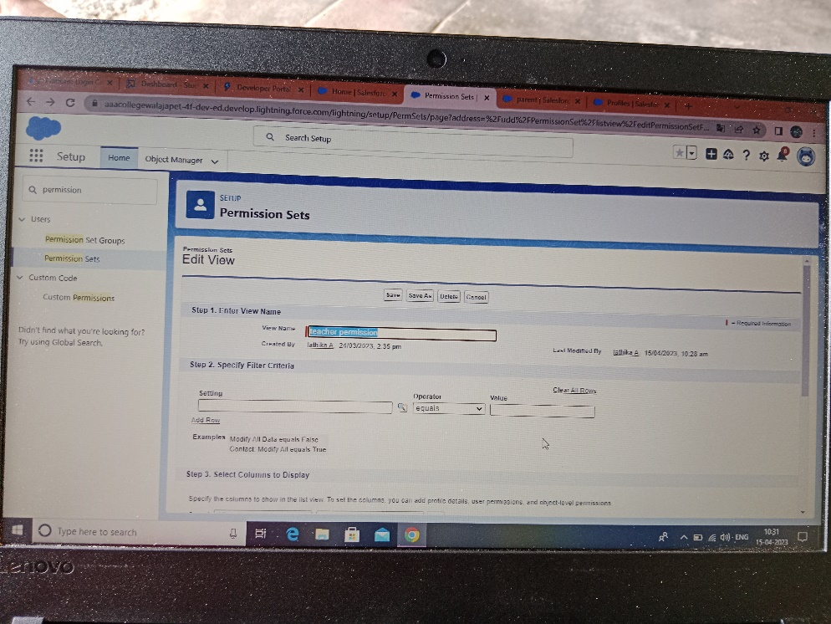

PERMISSION SET 2

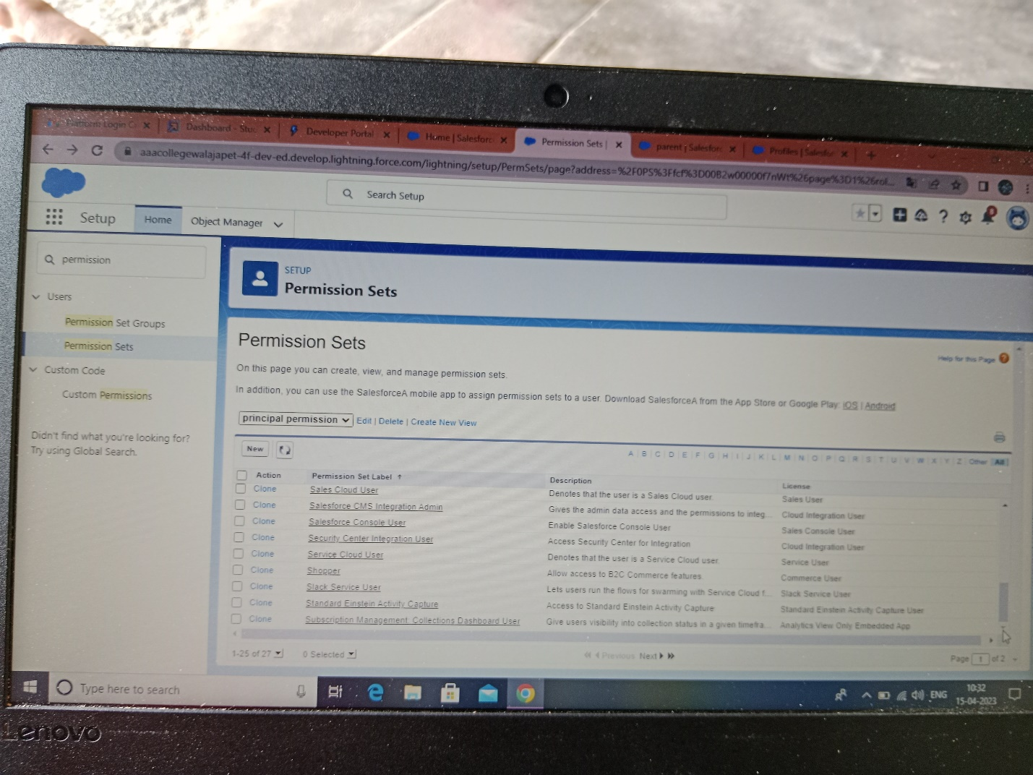

REPORTS

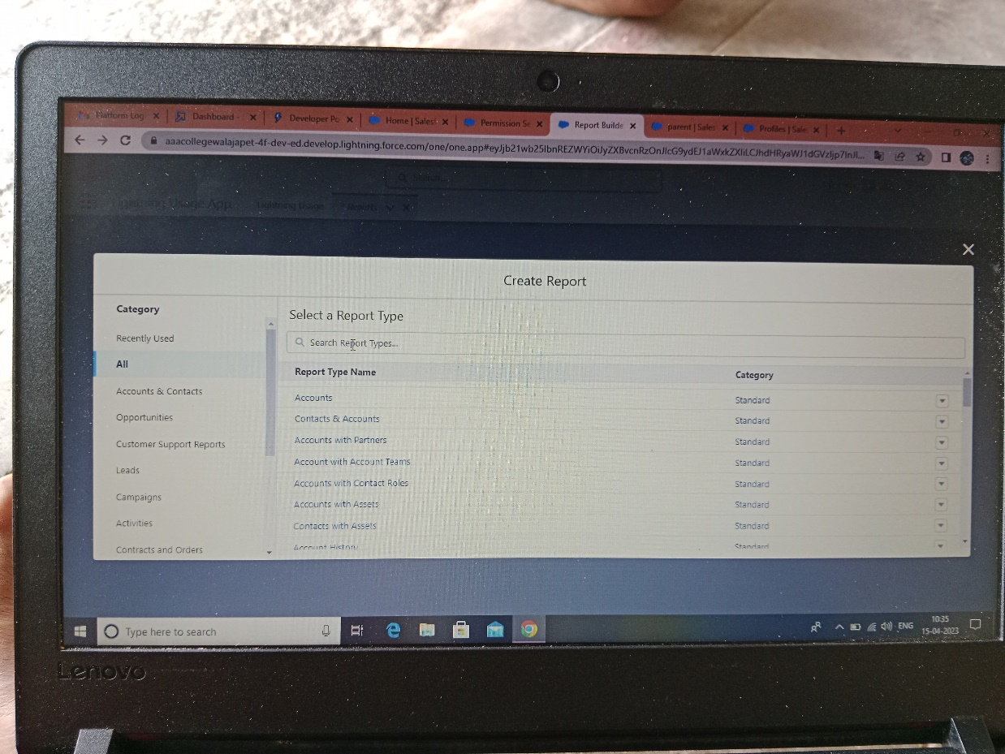

TRAILHEAD PROFILE PUBLIC URL

TEAM LEAD- <https://trailblazer.me/id/slathika>

TEAM MEMBER 1- <https://trailblazer.me/id/kavie6>

TEAM MEMBER 2- <https://trailblazer.me/id/ikeerthi>

TEAM MEMBER 3- <https://trailblazer.me/id/msathiyan>

ADVANTAGES & DISADVANTAGES

As you switch to using a CRM software solution for schools, many benefits come along. Not only does it enhance your efficiency on the performance end but also enables you to foster your relationships with existing and potential students/ parents. Here are some of the common benefits,

INCREASED EFFICIENCY

* School CRM software automates many of the manual processes involved in student and parent communication, data management, and reporting.
* This can save schools time and resources, allowing them to focus on other important tasks.
* By having all relevant information in one place, staff can access student and parent data quickly and easily, reducing the need for manual data entry and improving accuracy.

BETTER STUDENT ENGAGEMEN

* It enables schools to track interactions with students and their parents, and provides a platform for personalized communication, this can help schools build stronger relationships with students, increase engagement, and provide a better overall experience.
* Schools can also use the software to send targeted communications and track student progress, helping to identify any areas of concern and address them promptly.

IMPROVED DATA INSIGHTS

* With all data stored in one place, schools can gain valuable insights into student behaviour, preferences, and trends. This information can be used to make informed decisions about admission processes, student engagement, and resource allocation.
* School can also use the data to monitor student progress and identity areas for improvement.

ENHANCED REPUTATION MANAGEMENT

* School CRM software helps schools in managing their reputation by tracking student satisfaction and addressing concerns in a timely manner.
* By having all relevant information in one place, schools can respond to student and parent inquiries more efficiently and effectively.
* This can help schools maintain a positive image and build stronger relationships within the community.

INCREASED ADMISSIONS

* School CRM software can automate many of the tasks involved in student enrollment, allowing schools to reach more prospective students and increase admissions.
* By using the software to track student interactions and send targeted communications, schools can improve them outreach efforts and increase their chances of attracting new students.

BETTER ALUMNI MANAGEMENT

* A CRM can help schools keep in touch with alumni and tap into their networks for fundraising and recruitment.
* Schools can use the software to track alumni interactions, send targeted communications, and organise events.
* This can help schools maintain strong relationships with their alumni and leverage their networks to support their mission.

APPLICATION

* AUTOMATED MARKETING: The software can automate marketing tasks such as email campaigns, SMS messaging, and social media outreach, allowing schools to reach more prospective students.
* LEAD MANAGEMENT: A CRM can help schools track and manage leads, providing a centralised database of prospective students. This allows schools to prioritize leads and follow up with them in a timely manner.
* PERSONALIZED COMMUNICATION: By tracking student interactions and preferences, schools can send personalized communications that are more likely to resonate with prospective students.
* DATA INSIGHTS: The software provides valuable insights into student behaviour and preferences, allowing schools to make informed decisions about their recruitment efforts.
* IMPROVED OUTREACH EFFORTS: With all data in one place, schools can analyse trends and make data-driven decisions about their outreach efforts. This can help schools reach the right students with the right message, increasing the chances of attracting new students.

CONCLUTION

Overall, school CRM software can help schools streamline the enrollment process, reach more prospective students, and increase admissions. It helps schools and preschools in managing student data and interactions, automate tasks related to recruitment and enrollment, and improve the efficiency of their recruitment and retention efforts. It can also help to increase the effectiveness of enrollment campaigns. SCHOOL MANAGEMENT CRM APPLICATION enables you to do all this and much more on a unified platform. Schedule a demo today and learn more about a purpose-built growth solution for schools.

FUTURE SCOPE

* Customer Relationship Management is the best means to reach your customers and serve them in the best way. It automates all those tasks which enterprises used to perform manually.
* Every organization it set up with some frustrated ambitions and targets. The better the performance of your business, the better the relationship with your customers will be.
* CRM software development can turn your business into a powerhouse of sales. Thus, CRM software is no longer essential, in fact mandatory for small and medium business.
* Now, you can easily access the CRM software virtually from anywhere and anytime. All you need an internet connection to further the scope of doing your business.
* So, don’t be late and perform the necessities for implementing the CRM software in your business.